Reference: {reference}

Vehicle: {registration} / {make} / {model}

Principal:
{principal.business}
{principal.address}

Reference: ref123

Vehicle: XXX 123 / Audi / A3

Principal:
Super Insurer
221b Baker Street, London

{#make == ‘Audi’}
I like this car
{/}

I like this car

{#repairCosts.items}
{estimatedWithVat} {agreedWithVat} {savingWithVat}
{#}
100.00 100.00 0.00
100.00 100.00 0.00
{#repairCosts.items}  {estimatedWithVat} | {agreedWithVat} | {savingWithVat}{#}

100.00 | 100.00 | 0.00
100.00 | 100.00 | 0.00

- {-w:p repairCosts} {label} {agreedWithVat} {/repairCosts}
- Time 100.00
- Materials 100.00
{~~ comment}
This is a paragraph of comments
{% imageUrl}

{% imageBase64}
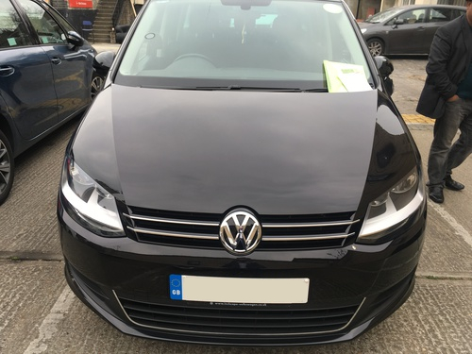



{#files.photos}
{% url}
{name}
{/files.photos}

image.jpg

